Kannapolis Middle School Library Collection Analysis

North Carolina’s Professional Standards for School Library Media Coordinators (2012) states that it is the responsibility of the Media Coordinator to develop “a library collection that supports 21st century teaching and learning” (Standard 3). The Media Coordinator must continuously evaluate the library collection to ensure that the holdings are accurately represented and current. The collection should provide for teacher and student needs for recreational reading and educational, curriculum-based needs in a variety of formats. The collection should also reflect the developmental, cultural, social, and linguistic needs of its diverse students. (NCDPI, 2012).
The purpose of this document is to analyze the overall collection of materials in the school library for the age, condition, and relevancy to the academic needs and interests of its patrons. Follett’s Destiny Library Manager (2018) and Titlewise Collection Analysis (2018) tools will be used to collect data of the library collection and usage statistics.

Library Overview

The Kannapolis Middle School and Eagles Nest Libraries serve 1,300 students in grades six through eight. There are two libraries on the KMS campus, one in the 6th grade building and one in the 7th and 8th grade building. The Eagles Nest Library in the 6th grade building has over 8,500 items including sets of fiction and non-fiction text, the reference collection, and the professional collection of books and videos (Follett, 2018). The KMS Library houses approximately 10,000 items including the majority of the fiction and non-fiction collection. Combined, these two facilities contain approximately 18,300 items with an average copyright age of 2004 (Follett, 2018). Based on the number of students, this is 14 books per student, which is slightly lower than the 15 items per student that North Carolina Department of Public Instruction (2016) recommends for school library collections as a “minimum quantity standard” to be considered a “developing” library. Ideally the collection should be current within 10 years and have 20 books per student, which would then achieve an “outstanding” rating. These figures are misleading in that the Eagles Nest Library contains multiple-copy sets of books and leveled readers, many of which are paperback, for group reading and class instruction. These items have been relocated onto the shelves for the 6th grade library. Without these items the collection would contain less than 10,000 books averaging only 7.6 books per student (Titlewave, 2018).
The KMS and Eagles Nest Libraries contain ninety-nine percent print materials with 56% of the collection in fictional literature. The average copyright age of the fiction collection is 2005, with 4,600 items in the regular collection and 5,700 items in the Eagles Nest Library (Titlewave, 2018).
Combined Totals
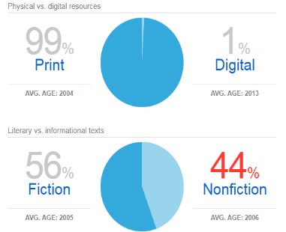(Titlewave, 2018)

Library Statistics

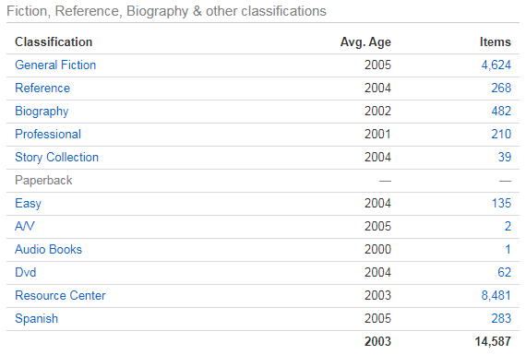
(Titlewave, 2018)

The collection has over 15,000 books that range from the 4th through 6th grade reading level, with an additional 1,500 books above and 1,500 below this range. 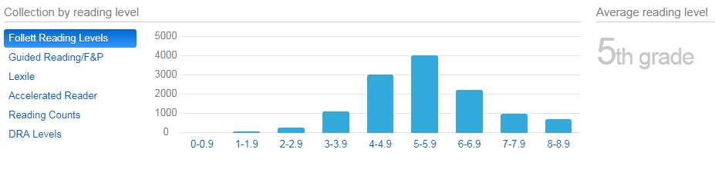
(Titlewave, 2018)

There are 6,000 books in the Lexile range of 675 to 900 with the collection average of 770 (Titlewave, 2018). An area of concern is that there are minimal selections in the BR - 199 or 1299 and above for the lowest and highest achieving readers.

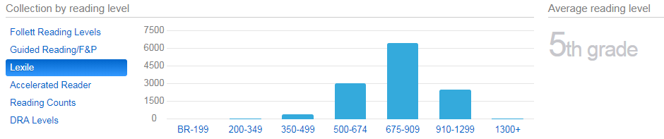
(Titlewave, 2018)
The non-fiction collection in the KMS and Eagles Nest Libraries contain approximately 3,700 books and an additional 500 biographies.
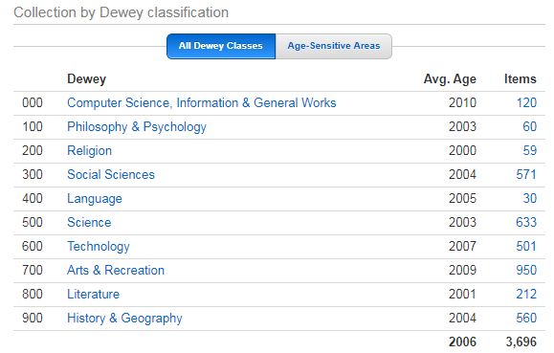
(Titlewave, 20198)
Further analysis of the breakdown of the non-fiction materials in the Eagles Nest Library is shown in the chart below. There are 1,400 non-fiction items in the Eagles Nest Library (Titlewise, 2018). These figures do not include the professional collection, or reference collection materials.

Eagles Nest Library | (6th Grade Library)
Total | 8481 | 46.3
RC Fiction | 6650 | 36.5
RC NonFic | 1400 | 7.7
000 | 0 | .0
100 | 15 | .8
200 | 54 | .3
300 | 309 | 1.7
400 | 35 | .3
500 | 174 | .95
600 | 112 | .61
700 | 115 | .61
800 | 210 | 1.1
900 | 632 | 3.5
RC 920/921 | 225 | 1.2
RC E | 160 | .87
RC Spanish | 55 | .3

Of the 18,300 items in the entire collection 2,200 items have copyrights of 2013 and above, which represents only 12% of the collection. Notably, only 677 titles have a copyright of 2013 or above, indicating that the majority of the 2,200 books are the literature sets in the Eagles Nest Library. Over 58% of the collection is deemed as “aged” indicating that the copyright dates are 10 years or older in general classifications or 5 years in age-sensitive categories such as science and technology (Titlewave, 2018)

Aged Materials, by Category

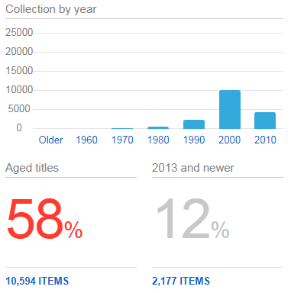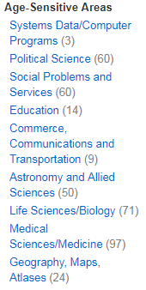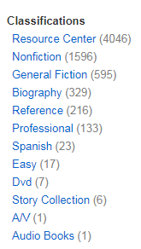
(Titlewave, 2018)

Non Print Collection

Through the Department of Public Instruction of North Carolina, Kannapolis Middle School has access to online databases through NC WiseOwl (2018) but no additional databases are purchased through school or district funds. However, many open-access sources and websites provide free materials for student and faculty use, such as Epic! books (2018). The non-print collection contains 64 DVDs, 1 audio book, and 98 ebooks, representing less than one percent non-print materials in the collection. The average age of the digital collection is well within an acceptable range, with an average of 2014 copyright year, however, the number of items in the collection is well below what a library needs to serve 1,300 students (IMPACT, 2005). There are also several Dewey categories that do not have any electronic resources available in single or multi-user format. The libraries electronic resources are curriculum based and are intended to support instruction, some of which are simultaneous multi-user copies of fiction and nonfiction titles.

Non Print  Resources | Number  of Items | % of  total | Copyright  Year | Circulations  2015 | 2016 | 2017
ebooks/AV | 104 | .65 | 2013 | 1 | 29 | 4
DVD | 64 | .35 |  | 28 | 31 | 2
Databases | 0
TOTAL non-print | 168 | 100 | 2013 | 29 | 60 | 6
(Titlewave, 2018; Destiny, 2018)
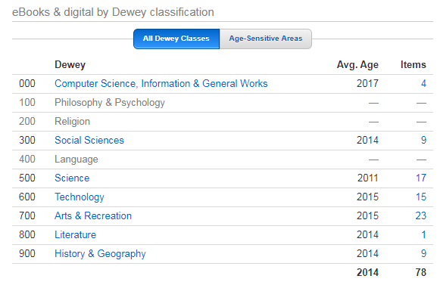
(Titlewave, 2018)

Collection History

Because Kannapolis Middle School Library’s collection was divided between two school buildings in 2018, the statistics presented in the charts do not provide a complete picture of the access, distribution, and circulation of the collection. Thus a more in-depth analysis was required to gain further information and insight. In the 2017-2018 school year, the new building which was to house the 7th and 8th grade students was still under construction, so the entirety of the 6th grade could not be moved onto the campus until January 2018. Three hundred students remained in what was formerly the Kannapolis Intermediate School, which had been converted into an elementary school serving kindergarten through fifth grade. In January of 2018 the 825 7th and 8th grade students were moved to the new middle school building and 475 6th grade students were brought into the old middle school building. This is when the library collection was relocated and divided into the KMS Library and the Eagles Nest Library. The KMS Resource Center materials, which consisted of 1,100 titles with over 8,500 copies of fiction and non-fiction book sets, reference materials, professional collection, and the DVD collection were moved onto the main shelves in the 6th grade library, to henceforth be named the Eagles Nest Library. The primary collection of 9,800 copies of 8,400 titles in fiction and non-fiction were moved to the library in the new 7th and 8th grade building, now called the KMS Library (Destiny, 2018).
In the chart below, the divided collections are represented with as much data as could be retrieved from Follett Titlewise Analysis (2018) and Destiny Library Manager (2018). Some reports could not be generated, such as copyright dates of the specific categories of the Resource Center materials. As it was not critical to the overall analysis of the collection, these fields were left blank.
KMS Library Collection Worksheet

School name: _Kannapolis Middle School___ Grade levels: __6-8____ Number of students: __1300____

Category | Number  of Items | % of  total | Copyright | Circulation  2015-16 | Circulation 2016-17 | Circulation 2017-18
KMS and Eagles Nest Libraries
TOTAL Print | 18100 | 99 | 2004 | 15338 | 15795 | 14881
Fiction | 10,300 | 57 | 2005 | 11109 | 11043 | 9797
NonFiction | 7,300 | 43 | 2004 | 3481 | 4662 | 4967
Reference | 268 | 1.5 | 2004 | 139 | 20 | 27
Professional | 210 | 1.2 | 2001 | 17 | 4 | 11
TOTAL Non Print | 168 | .92 | 2013 | 29 | 60 | 6
ebooks | 104 | .6 | 2013 | 1 | 29 | 4
DVD | 64 | .35 | 2012 | 31 | 28 | 2
Databases | 0
KMS Library | (7th/8th Grade Library)
Total Print | 9821 | 53.7 | 2005 | 9531 | 10777 | 11133 >3.2
000 | 120 | .7 | 2010 | 275 | 214 | 347 >62%
100 | 60 | .3 | 2003 | 42 | 31 | 34
200 | 59 | .3 | 2000 | 15 | 9 | 30
300 | 571 | 3.1 | 2004 | 159 | 270 | 376 >72%
400 | 30 | .15 | 2005 | 10 | 15 | 19
500 | 633 | 3.5 | 2003 | 246 | 157 | 350
600 | 501 | 2.7 | 2007 | 223 | 388 | 337
700 | 950 | 5.2 | 2009 | 2055 | 2241 | 2434
800 | 212 | 1.2 | 2001 | 55 | 172 | 134
900 | 560 | 3.1 | 2004 | 112 | 176 | 205
920 | 130 |  | 2002 | 17 | 51 | 39
921 Biography | 362 | 2.6 | 2002 | 90 | 130 | 128
Easy | 135 | .7 | 2004 | 48 | 24 | 42
Fiction | 4624 | 25.3 | 2005 | 5871 | 6607 | 6372 <4%
Spanish | 283 | 1.5 | 2005 | 182 | 238 | 221
Eagles Nest Library | (6th Grade Library)
Total | 8481 | 46.3 | 2003 | 5807 | 5018 | 3748 <25%
RC Fiction | 6650 | 36.5 |  | 5238 | 4436 | 3425 <23%
RC NonFic | 1400 | 7.7 |  | 551 | 570 | 313 <45
000 | 0 | .0 |  | 0 | 0 | 0
100 | 15 | .8 |  | 2 | 2 | 2
200 | 54 | .3 |  | 32 | 7 | 2
300 | 309 | 1.7 |  | 120 | 166 | 37
400 | 35 | .3 |  | 0 | 0 | 0
500 | 174 | .95 |  | 7 | 9 | 10
600 | 112 | .61 |  | 20 | 46 | 38
700 | 115 | .61 |  | 44 | 57 | 39
800 | 210 | 1.1 |  | 37 | 80 | 80
900 | 632 | 3.5 |  | 393 | 230 | 114
RC 920/921 | 225 | 1.2 |  | 213 | 102 | 68
RC E | 160 | .87 |  | 14 | 9 | 10
RC Spanish | 55 | .3 |  | 9 | 6 | 4
Professional | 210 | 1.1 | 2001 | 17 | 4 | 11

Although the actual percentages of the collection are below the recommended number in all Dewey categories, the data is misleading because 46% of the collection, the Resource Center materials, are not accurately reflected in the totals in the chart below. The fiction materials available in both libraries represent 61.5% of the collection. Also, Spanish language materials, and electronic resources in Dewey categories are not represented in the sub-categories on the chart below. The science materials, identified as being 10% below recommendation require further analysis for currency, appropriateness to the curriculum, as well as number of materials available.
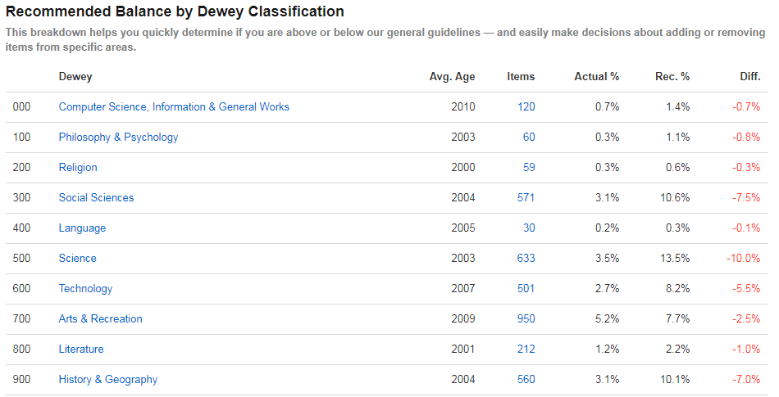
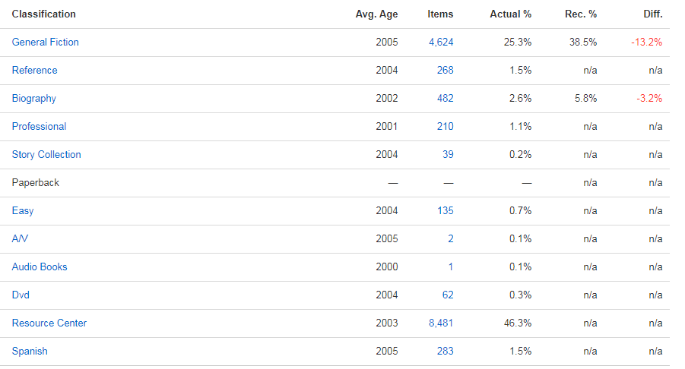
(Titlewave, 2018)

When analyzing the KMS and Eagles Nest libraries’ collection several considerations and concerns are noted. With the dramatic change in the size of the student body, from 825 to 1,300 students, there was no allocation of funds to provide for the additional 475 students being added to the middle school campus. The collection had been weeded in the 2015 - 2016 school year in anticipation of a grant provided through the district on a three year rotation, but with the restructuring of the district to accommodate magnet programs and the reversion to a standard K-5, 6-8, 9-12 school organization, Kannapolis Middle School was deferred for two years and did not receive the grant funds. Approximately 3,000 dated materials had been removed from the collection, but the school was unable to purchase books for the collection to replace those weeded.
The chart below shows that even though funding was obtained through grants written by the library media coordinator, the items lost, including those not returned by patrons and items missing through an annual inventory, far exceeded the number of books added to the collection over the previous three years. This issue continues to be a challenge for the Kannapolis Middle School libraries. Students are not able to pay for lost books, or choose not to do so. The school district does not hold report cards or have other punitive measures to ensure that materials are returned. Policies have been put in place to try to resolve this issue including competitions for classrooms where prizes are awarded to teachers and students who return the most books. A new library policy was implemented in 2016 which allows for fines to be forgiven if students donate replacement books. However, these materials are not usually a suitable replacement for the lost items, as they are aged, in poor condition, or not appropriate for inclusion in the library.
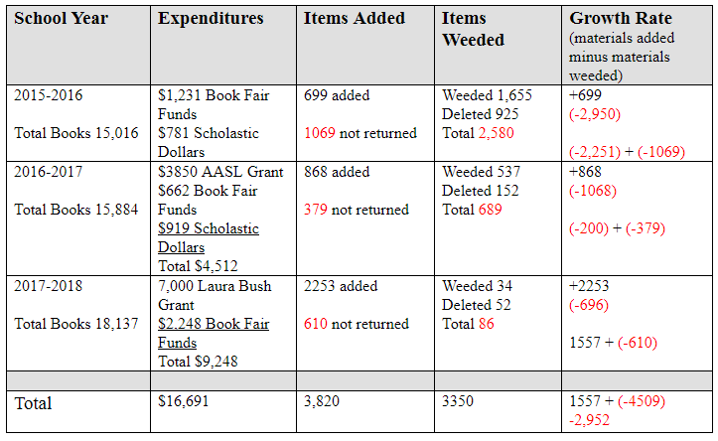
(Destiny, 2018)

Another cause for concern is the fact that the library, staffed with only one assistant and one media coordinator for two buildings, is not equipped to maintain the collection without funding and staffing to prevent loss of items and subsequent need for replacement of books. Funding is needed to provide books with current copyrights and highly desirable titles for circulation. To properly manage the collection, staffing is needed in each location, so that services to assist patrons can be provided and can minimize items being improperly checked out of the library which then translates into the loss of items at the “self-service” desk. The lack of staffing also prohibits oversight of circulation to patrons with multiple items that have not been returned, increasing the net loss of collection materials. With current replacement costs for a trade paperback book over $10 and hardback book average cost of $20 (SLJ, 2018) a conservative estimate of $15 per book translates to a loss of $45,000 in the last three years with a deficit of 3,000 books.

Overall Collection Assessment

In the last five years the librarian has actively pursued grant funding to update and diversify the collection and was awarded the AASL Collection Development grant for multicultural non-fiction, Spanish language, and multicultural fiction and the Laura Bush Foundation Collection Development Grant for STEAM books to support the makerspace initiative. However, the fiction collection and high-interest non-academic categories, such as sports and graphic novels have had to rely on library fundraising efforts through Scholastic Book Fairs, personal purchases by the school librarian and donations from the KMS Parent Teacher Student Organization to provide for students’ requested titles and to maintain popular series of books. Also, modern biographies, fact books, and sports books are in dire need of updating and replacement as they are no longer current and in poor condition. Books in popular fiction and series are the most requested materials in the middle school library. Kannapolis Middle School and the Eagles Nest Library collections are in need of popular titles in all fiction genres, especially graphic novels, sports, humor, and realistic fiction for all age and ability levels of the students being served. With 3,000 of the 4.600 fiction books with copyrights in the 1990’s and early 2000’s (Titlewave, 2018), the collection is lacking current fiction titles and the subsequent books in popular series. There are 1,400 books with copyright of 2010 to 2018, but the average is 2013 copyright (Titlewave, 2018).
Overall, the non-fiction collection is considered to be dated, with a 2004 copyright, but most materials are still relevant to the collection (IMPACT, 2005). Some weeding needs to occur, but most items are still viable. Content must be added to correlate with the 6th grade science and social studies curriculum. Also, with the emphasis on social justice in the 8th grade curriculum, books in the social sciences, the 300’s, need to be updated. Additionally, to meet the needs of student interests, books about animals, sports, art, drawing, and general fact books must be added to the collection in current copyrights.
KMS Library serves a large population of Hispanic students, many of whom are bilingual, limited English, or non-English proficient. The KMS Library collection contains less than two percent of its collection in bi-lingual or Spanish language materials. The AASL Collection Development Grant in 2016 almost doubled the size of the Spanish language collection however, with less than 2% of the overall collection and no Spanish language materials in the Eagles Nest Library this is another area of need. Additionally, the Kannapolis City School Spanish Immersion program at the elementary level will feed into the middle school and additional print materials will be needed for these bilingual students.
In addition to books, students find the visual format of magazines quite engaging and because of the frequency of their publication are a perfect source to provide students with current information in print format, especially for our populations that are not Internet-connected outside of school. Magazines are excellent materials for recreational reading as well as for enrichment and intervention in the classroom. Neither the Eagles Nest Library nor the KMS Library have print periodicals, and funding for these materials should be a priority to add these to the collection.

Eagles Nest Library

The Resource Center book collection was originally designed to meet the needs of literature circles for 7th and 8th grade classrooms, and many of the titles are better suited to the upper grade levels. Additional titles are needed for the Eagles Nest Library to meet the needs and interests of the 6th grade students who do not have regular access to the general collection housed in the 7th and 8th grade library. The Eagles Nest Library should provide independent reading selections and curriculum-based materials in both print and electronic format to support 6th grade science, social studies, and English language arts curriculum. In order to support the science and social studies standards, the collection needs current print materials in addition to online sources that connect students to the ever-changing world of science and technology, history, current issues, and other relevant, timely topics. The Eagles Nest Library does not contain graphic novels, sports, science, popular series, or other high interest, current copyright fiction or nonfiction that match student interests or the 6th grade curriculum.

Circulation Statistics

An area for concern is the statistical data showing a 10% decrease in overall circulation during the 2017-2018 school year. Resource Center material circulation decreased approximately 25% in the same year. There are several known factors which affected the collection usage. In part this decrease can be explained with the transition from one library to two libraries and the move to the new building which brought changes in routines and a new 3-week rotation schedule for library visitation. Classes previously were in a two week rotation, which meant that all 800 7th and 8th grade students visited the library twice a month. With the addition of the sixth grade the three week rotation was adopted in February of 2018. Another factor affecting circulation was that the eighth grade teachers worked in collaboration with the University of North Carolina Charlotte on a writing program and discontinued their curriculum based literature circles in which resource center materials were used for student book clubs each nine weeks. Also, because of this initiative, the eighth grade did not come to the library for a bi-weekly check-out which dramatically reduced the circulation of books through student check-outs for their grade level. They rank third of the three grade levels in number of items checked out by students. Sixth grade statistics represent the circulation data from when these students attended Carver Elementary School.
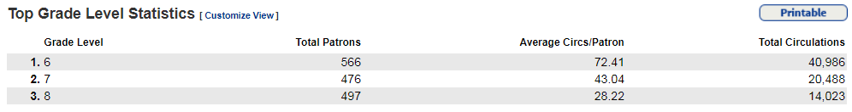
(Destiny, 2018)
In a report of top classrooms with checkouts in Destiny (2018) only one 8th grade homeroom ranked in the top 20. Sixth grade students, though only on campus for the last nine months have the highest per student and classroom checkout statistics of all grade levels (Destiny, 2018).
Secondly, the reorganization of the school district, which was greatly impacted by the new school being delayed and unable to open for the first half of the 2017-2018 school year, greatly affected the circulation of library materials, instruction, and use of the libraries on the KMS campus. For approximately seven months of the school year many of the 6th grade students had to use the Carver Elementary School Library. Although the KMS student body numbered 1,300 students, not all of the students were able to use the library during this transition time.
Now that all 1,300 students are on the same campus and have a regularly scheduled checkout and flexible use of both libraries, as well as in-house library loan between the two libraries, circulation and usage are increasing. The eighth grade team has reinstated literature circles and are actively participating in the library advisory team for selection of new materials.
Overall, the KMS and Eagles Nest Libraries provide a collection that enhances and supports the curriculum for the teachers and encourages literacy for both academic and personal interests of the students. While there are issues with currency and condition of materials, there are a wide variety of books and a continuous supply of new materials being added to the collection each year through fundraising and grant writing efforts. Ongoing analysis of circulation data and collection development will strengthen and align the collection to the needs of its patrons.
References

Destiny. (2018) Collection circulation report. Retrieved from http://destiny.kcs.k12.nc.us

Destiny. (2018) Library title and copy list. Retrieved from http://destiny.kcs.k12.nc.us

Destiny. (2018). Library weeding log. Retrieved from http://destiny.kcs.k12.nc.us

Epic! (2018). About Epic! Retrieved from https://www.getepic.com/about

North Carolina Department of Public Instruction. (2018). NC WiseOwl. Retrieved from
http://www.ncwiseowl.org/

North Carolina Department of Public Instruction. (2012). North Carolina School library media
coordinator standards. [PDF file] Retrieved from http://www.dpi.state.nc.us/docs/effectiveness-model/ncees/standards/media-spec-standards.pdf

Public Schools of North Carolina. (2005) IMPACT: Guidelines for North Carolina media and
Technology. [PDF file] Retrieved from http://www.ncpublicschools.org/docs/dtl/resources/impact/3impact-revision.pdf

Scholastic. (2018). Book fair history. Retrieved from
https://bookfairs.scholastic.com/bookfairs/cptoolkit/fairhistory/fair_history.jsp?destination=withoutnav

School Library Journal (2018, March 21). SLJ's Average Book Prices for 2018. Retrieved
from https://www.slj.com/?detailStory=sljs-average-book-prices-2018

Titlewave. (2018). Titlewise collection analysis: Kannapolis Middle School
Library collection. Retrieved from
http://www.titlewave.com/titlewise/dispsingle?caid=3164549

Kannapolis Middle School Library Analysis
Kelly J. Beckham
LIS 653 Fall 2018
UNCG

